Comparison: Amazon RDS Multi-AZ and Read Replicas.

TL;DR:

Amazon RDS Multi-AZ and Read Replicas maintain a copy of database but they are different in nature.

Use Multi-AZ deployments for High Availability/Failover and Read Replicas for read scalability.

Amazon RDS Multi-AZ

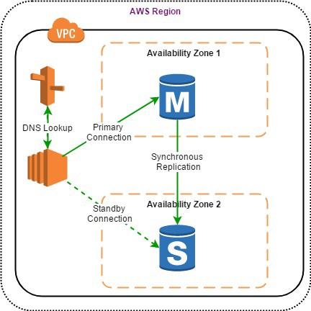

Amazon RDS Multi-AZ deployments provide enhanced availability for database instances within a single AWS Region. With Multi-AZ, your data is synchronously replicated to a standby instance in a different AZ.

In the event of an infrastructure failure, Amazon RDS performs an automatic fail-over to the standby, minimizing disruption to your applications without administrative intervention.

## **Benefits of Multi-AZ deployment:**

* Replication to a standby replica is synchronous which is highly durable.
* Endpoint of DB instance remains the same after a failover, the application can resume database operations without manual intervention.
* If a failure occurs, your availability impact is limited to time that automatic failover takes to complete. This helps to achieve increased availability.
* It reduces the impact of maintenance. RDS performs maintenance on the standby first, promotes the standby to primary master, and then performs maintenance on the old master which is now a standby replica.
* To prevent any negative impact of the backup process on performance, Amazon RDS creates a backup from the standby replica.
* When a problem is detected on the primary instance, it will automatically failover to the standby in the following conditions: 1) The primary DB instance fails. 2) An Availability Zone outage. 3) The DB instance server type is changed. 4) The operating system of DB instance is undergoing software patching. 5) Manual failover of DB instance was initiated using reboot with failover.

# Amazon RDS Read Replicas

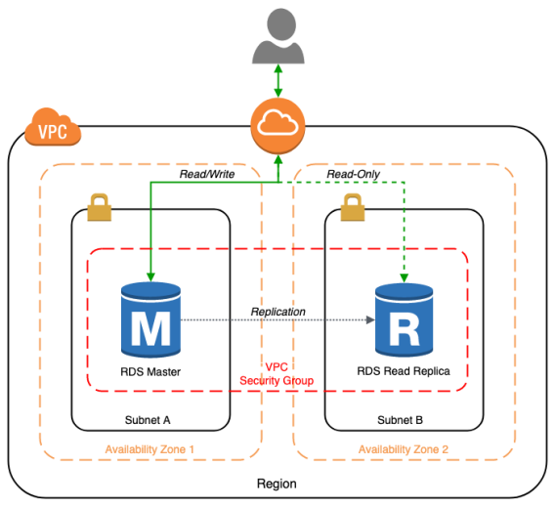

[Amazon RDS Read Replicas](https://aws.amazon.com/rds/details/read-replicas/) enable you to create one or more read-only copies of your database instance within the same AWS Region or in a different AWS Region to increase the scalability.

Updates made to source database are then asynchronously copied to Read Replicas. Writes can happen in main database only and reads can happen in Read replica database.

When you create a Read Replica, you first specify an existing DB instance as the source. Then Amazon RDS takes a snapshot of the source instance and creates a read-only instance from the snapshot. The source DB must have automatic backups enabled for setting up read replica.

## **Benefits of Read Replicas**

* Read Replicas helps in decreasing load on the primary DB by serving read-only traffic.
* You can create Read Replicas within AZ, Cross-AZ or Cross-Region.
* Read Replica can be manually promoted as a standalone database instance.
* Read Replicas support Multi-AZ deployments.
* You can use Read Replicas to take logical backups, if you want to store the backups externally to RDS.
* You can have Read Replicas of Read Replicas.
* Read Replica helps to maintain a copy of databases in a different region for disaster recovery.
* You can have up to five Read Replicas per master, each with own DNS endpoint. Unlike a Multi-AZ standby replica, you can connect to each Read Replica and use them for read scaling.

## **Read Replicas Use Cases**

* Business reporting or data warehousing scenarios where you might want business reporting queries to run against a read replica, rather than your production DB instance.
* Implementing disaster recovery. You can promote a read replica to a standalone instance as a disaster recovery solution if the primary DB instance fails.
* Scaling beyond the compute or I/O capacity of a single DB instance for read-heavy database workloads. You can direct this excess read traffic to one or more read replicas.
* Serving read traffic while the source DB instance is unavailable. In some cases, source DB instance might not be able to take I/O requests, for example due to I/O suspension for backups or scheduled maintenance. In these cases, you can direct read traffic to your read replicas.

Backups vs snapshots

Q: What is the difference between automated backups and DB Snapshots?

Amazon RDS provides two different methods for backing up and restoring your DB instance(s) automated backups and database snapshots (DB Snapshots).

The automated backup feature of Amazon RDS enables point-in-time recovery of your DB instance. When automated backups are turned on for your DB Instance, Amazon RDS automatically performs a full daily snapshot of your data (during your preferred backup window) and captures transaction logs (as updates to your DB Instance are made). When you initiate a point-in-time recovery, transaction logs are applied to the most appropriate daily backup in order to restore your DB instance to the specific time you requested. Amazon RDS retains backups of a DB Instance for a limited, user-specified period of time called the retention period, which by default is 7 days but can be set to up to 35 days. You can initiate a point-in-time restore and specify any second during your retention period, up to the Latest Restorable Time. You can use the [DescribeDBInstances](http://docs.aws.amazon.com/AmazonRDS/latest/APIReference/API_DescribeDBInstances.html) API to return the latest restorable time for you DB instance, which is typically within the last five minutes. Alternatively, you can find the Latest Restorable Time for a DB instance by selecting it in the [AWS Management Console](https://console.aws.amazon.com/) and looking in the “Description” tab in the lower panel of the Console.

DB Snapshots are user-initiated and enable you to back up your DB instance in a known state as frequently as you wish, and then restore to that specific state at any time. DB Snapshots can be created with the [AWS Management Console](https://console.aws.amazon.com/), [CreateDBSnapshot API](http://docs.aws.amazon.com/AmazonRDS/latest/APIReference/API_CreateDBSnapshot.html), or [create-db-snapshot command](http://docs.aws.amazon.com/cli/latest/reference/rds/create-db-snapshot.html) and are kept until you explicitly delete them.

The snapshots which Amazon RDS performs for enabling automated backups are available to you for copying (using the AWS console or the [copy-db-snapshot command](http://docs.aws.amazon.com/cli/latest/reference/rds/copy-db-snapshot.html)) or for the snapshot restore functionality. You can identify them using the "automated" Snapshot Type. In addition, you can identify the time at which the snapshot has been taken by viewing the "Snapshot Created Time" field. Alternatively, the identifier of the "automated" snapshots also contains the time (in UTC) at which the snapshot has been taken.

Please note: When you perform a restore operation to a point in time or from a DB Snapshot, a new DB Instance is created with a new endpoint (the old DB Instance can be deleted if so desired). This is done to enable you to create multiple DB Instances from a specific DB Snapshot or point in time.

Point-in-time recovery in the context of computers involves systems, often databases, whereby an administrator can restore or recover a set of data or a particular setting from a time in the past